Repositorio GIT

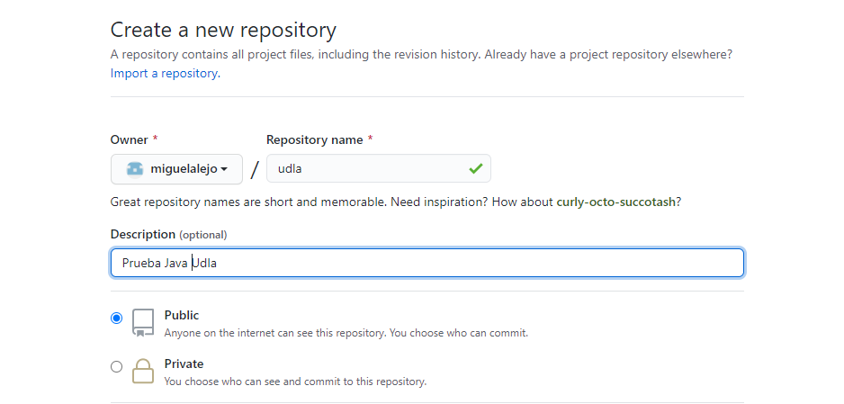

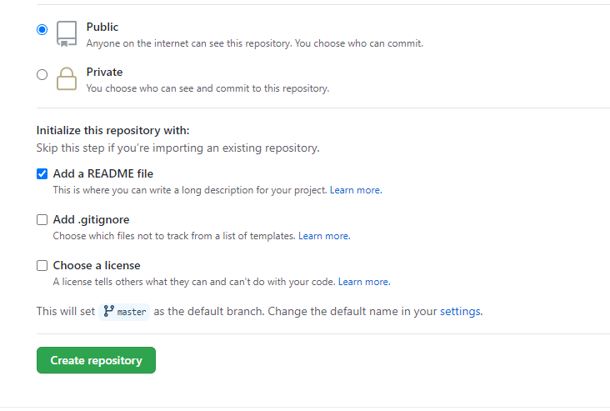

Configuraciones Elcipse

Instalar Plugi in GIT

Installing Spring Tool Suite (STS)

<http://12factor.net>)